12/10/2016

Wikipedia

Final Project Report



Akshay Choudhary

Garima Deshpande

Priyanka Pagare

Tejas Washindkar

Contents

Introduction 2

Problem Statement 2

Project Team 3

Project Objectives 3

User Needs 3

Functional Specifications 5

Content Requirements 6

Error Handling 7

Information Architecture 7

Wireframes 8

Style Guides & Design Specifications 8

1. BRANDING 8

2. COLORS 9

3. TYPOGRAPHY 9

4. BUTTONS 10

5. ICONS 10

6. FORM ELEMENTS 10

Prototypes 11

User Research Methods 11

Usability Testing 14

Functional Testing 15

Technologies Used 15

# 

# Introduction

This document provides final report for the project Wikipedia created as a part of the curriculum for the User Experience Design & Testing course for fall 2016 semester. This is an extension to our mid-term project which described the problem statement, various elements of user experience such as product objectives, user needs and segmentation, functional requirements, content requirements and information architecture.

We have followed the best practices for designing a user experience project by using the concepts and methods mentioned in the book “The Elements of User Experience by Jesse James”. We have designed the project from all five planes adopting a top-down approach. Each component is documented in detail in the report. We have also created wireframes and prototypes for the website.

# Problem Statement

Wikipedia is a well-known website and ranks globally 6th as per <http://www.alexa.com> analytics, it still lacks on a major part of user experience. So we have come up with an idea of improving the front-end design of major modules of the website.

1. **Look and feel:**
2. The first impression that any particular user could get about the website is that it seems too old or obsolete considering the poor color scheme Wikipedia has adopted.
3. Header and Footer: Accustomed to the various websites that a user goes through every day the header part of Wikipedia is not organized as a user would not find the custom links that would navigate to different pages along with it the footer part is not aligned properly.
4. **Homepage:**
5. Structure of content on the homepage is not organized properly.
6. There is no consistency in information displayed on the main page since the content changes when the language is changed.
7. **Navigation Bar:**

Since the navigation bar is aligned vertically, it is occupying a lot of space on the page. A beginner will get confused with a lot of links available for navigation and has to scroll often to find a particular link.

1. **Wiki Search Result :**
2. When a user searches for a given topic on Wikipedia the result displays a content section which includes different points that occupies a lot of space above the actual information that a user wants about the searched topic.
3. Apart from the content index the actual information that is displayed needs to be organized in a collapsible bar so that the user can click on any of the bar and the particular result would be displayed instead of scrolling down to find the required information.
4. As we know pictures can convey more information then text which is not the case with Wikipedia search result where there are hardly any images for the user to grasp information quickly.
5. **Create Account:**

Account creation requires username and password but email is optional so a user can create multiple accounts and alter the information.

# Project Team

# Project Objectives

We have listed some of the objectives which should be achieved in order to fulfil our goals with the user experience perspective.

1. **Re-design and enhance the user experience of the website –**

As already discussed in the problem statement about the look-and-feel of the existing website, this objective will help us to create a website which will leave a good impression on the user with vibrant color scheme and pictures.

1. **Improve functional interactivity –**

This objective will help us create a website which has easy navigation for naïve users. The new website has many form validations such as when the user enters email address on the login form and if the email address does not exist in the database, it shows an error message that the email address does not exist.

1. **Provide security and make it more reliable –**

This objective will help us create a more reliable website by not allowing any user to edit source information without being logged in.

1. **Optimize site performance –**

This objective will help us to minimize maintenance cost and cost of the website after all the changes being implemented.

# User Needs

Wikipedia is used by diverse kind of users. 3 kinds of users are identified –

1. **Contributors –** People who develop and distribute information.
2. **Users –** People who browse information.
3. **Administrators –** People who monitor the content being uploaded and edited on the website.

Below are Persona’s created for the users –

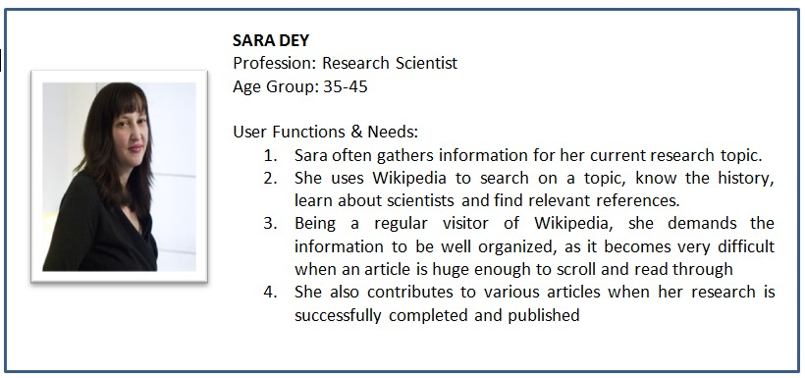

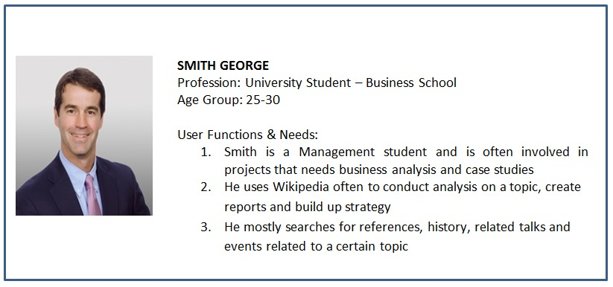

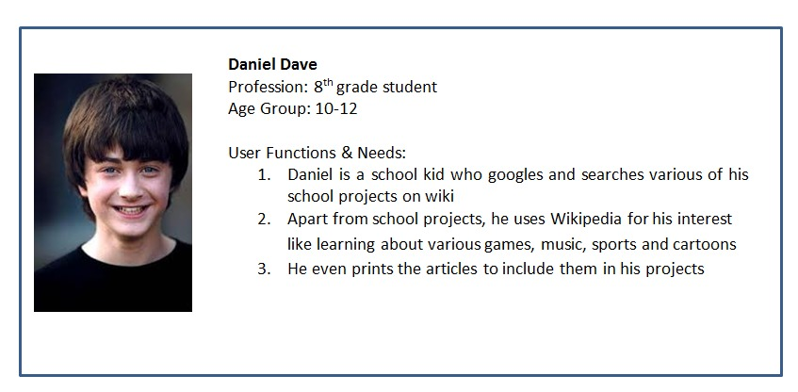

# Functional Specifications

1. **Read an article**

User should be able to search an article of his choice using the search bar. User should also be able to view current events, featured contents and articles published on Wikipedia. The information should be well structured and easy to access, categorized and concise.

1. **Publish an article**

Wikipedia gives a platform to the user to not only view information but also contribute to the information. Contributors can add to an existing article, edit an article or create a new article. Users can use Upload feature to upload any documents. The new design should allow editing or creating articles only to the logged in users.

1. **Create Profile**

User can create profiles to create or edit any articles, contribute to information, post events etc. Sign Up should be well validated to and user should be signed in using unique email id. Registration form will validate user email id if it exists and also check password to match password guidelines.

1. **Login**

A successful login should be done in order to access extra tools and features in Wikipedia. Login form should be well validated to check credentials.

1. **Search Results**

Search results are generated when user inputs something in the search bar or finds using google search. Search information should be well organized. There should be a content menu to access information quick and easy.

1. **View events and News**

Wikipedia provides a platform to view current or previous events. User can choose a date or a month or a year and have an overall review of news and events just like a news website. Information will show users information along with interactive pictures.

1. **Content and Featured content**

Latest or featured articles, popular contents are now available to the users on a separate page. The information is well organized with a lot of interactive features. This content can also be edited using the edit option on the page.

1. **Upload**

Wikipedia provides various tools for the user to contribute or use the existing information. One of the tools is Upload a document. It can be used to add pictures, pdf, word files or any other type of document.

1. **Print**

Any current information being viewed can be printed as a document using the Print and Export tool in Wikipedia. Users can also view the printable version using the tool under Print & Export. It will remove all the website specific formatting and provide a simple view that is required by the user as information in a pdf document.

# Content Requirements

Wikipedia has a wide variety of contents on its website out of which some are generated by the website while some are generated by the users of the website. Although content generated by the users of the website contribute more than the content generated by the administrators of the website. The content on the website includes displaying real life events on a particular day, in-depth information about any topic, community portal where users can contribute to some of the existing projects that need help. Users can even print the results generated by the search functionality. Based on these contents we have set some standards on this website:

* **Font**

1. As we might have seen on the actual Wikipedia website that there is no agreed upon font that has been used throughout and hence we have carefully reviewed this aspect and decided that font of the information should adhere to true-type format.
2. Also we have adapted a consistent font for different types of information throughout the website.

* **Image**

1. Pictures are a good way to explain information in depth and that what seems missing on the Wikipedia website. That is the reason we have included pictures in all our search results in the Wikipedia redesign so that the information could be self-explanatory and attract users to read more about it.

* **Language**

1. Another shortcoming on the main website that needs attention is the consistency in language throughout. If you try to search information in different languages then the results you get based on the language you selected are different. Thus the results should be consistent based on search conducted in different languages.

* **Concise Navigation Bar**

1. Information on the website doesn’t seems to be structured. Information is more spread out and needs a user to scroll down many times to get the full information. In order to address this issue we have considered using collapsible tabs for different categories of information that would eliminate the need of a user to scroll down continuously.
2. Along with collapsible tabs it is also a good approach to have concise navigation bar with more detailed tabs about different sections of information.

* **Aspect Ratio**

1. Another good approach would be to consider that news and events aspect ratio should be maintained throughout the website including the search results and at times where user needs to edit some information.

# Error Handling

Error handling is one of the most important aspect in creating or maintaining a website. In our website we have taken care of possible errors. All user forms are validated and error messages are displayed when needed.

Below is one of the sample of validation performed on login page-

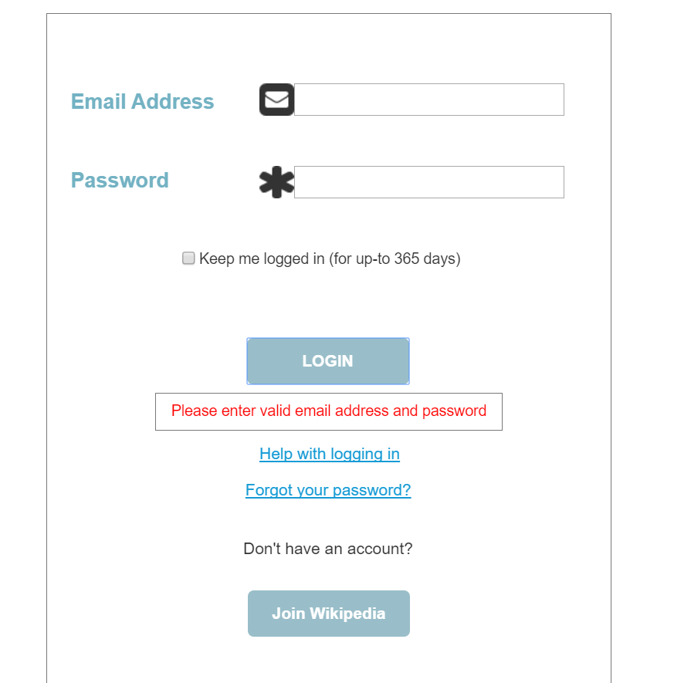

# 

# Information Architecture

Information Architecture refers to the organization of the information on the website and how it fits together. It focuses on organizing, structuring and labelling content in an effective and sustainable way. Its primary goal is to help users find information easily while adhering to the website’s objectives. We followed a top-down approach while creating the Information Architecture. We created the hierarchical architectural structure which suited best for our website.

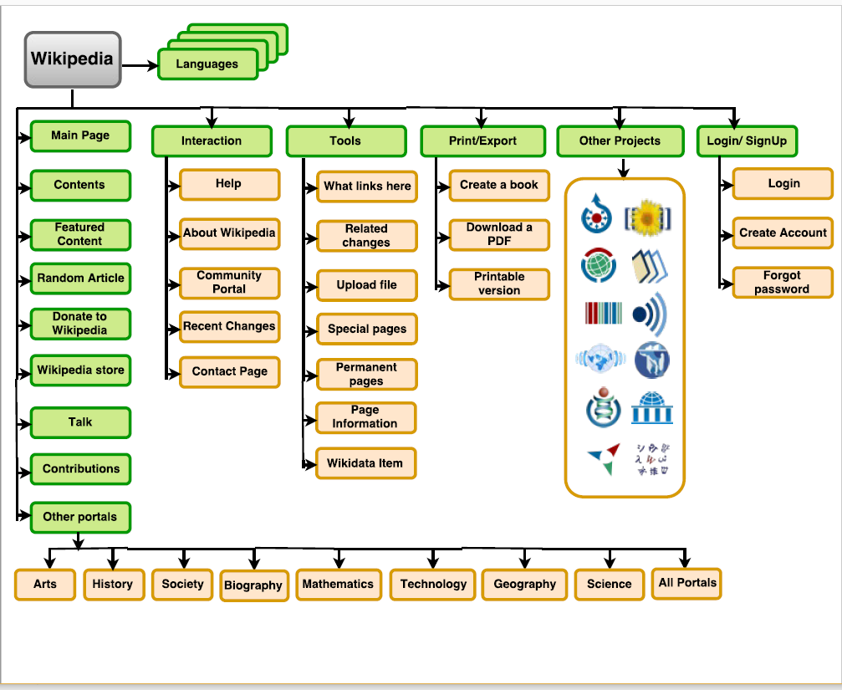

# Wireframes

As a part of re-designing the website, we have created wireframes to showcase the changes we would like to implement in the website. We used the Moqups online tool to create the wireframes. They are included separately in the submission folder with the name **Wikipedia.pdf**.

# Style Guides & Design Specifications

## BRANDING

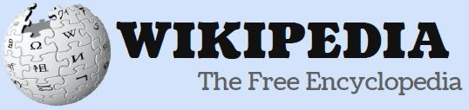



We are using these 2 logos for our website. The first logo we used in wireframes and the other one is used in prototype. The name itself speaks for the brand which is Wikipedia. Blue color is used to maintain original theme.

## COLORS

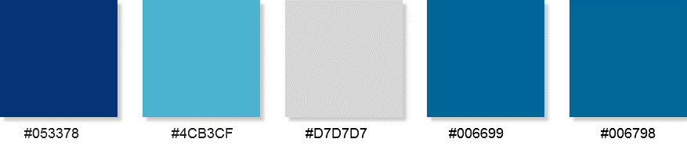

Color Palettes used in the website. Warm colors have been used since this is an information website, user spend a lot of time in reading. Hence we have used light and warm color coding which is eye-pleasing.

## TYPOGRAPHY

|  |
| --- |
| HEADER – Font Arial, Sans-Serif Size 32  SUB-HEADINGS – Font Arial, Sans-Serif Size 18, 24  General Text – Font Arial, Size 13, 16 |

Font type and size specifications implemented in our website.

## BUTTONS

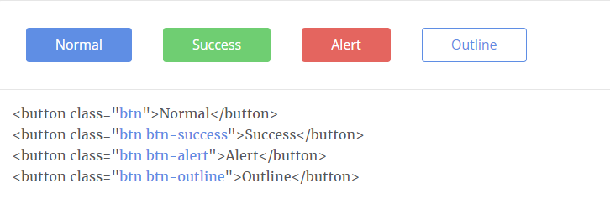

These are few of the buttons (Bootstrap based) used throughout the site.

## ICONS

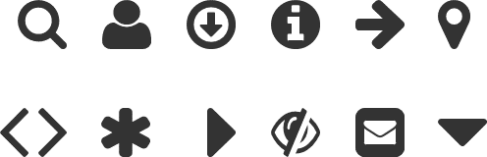

These are few of the icons used throughout the site. Size has been maintained to 35 x 35 px for control based display such as down button etc.

These are few of the icons used throughout the site. Size has been maintained to 24 x 24 px for integrating within table cells/Form Fields.

## FORM ELEMENTS

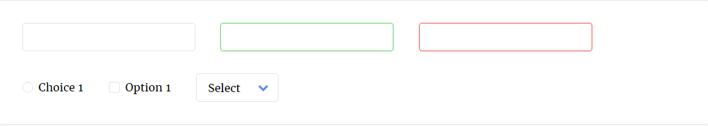

These are the form elements used in our website.

# Prototypes

After going through all the elements of user experience such as identifying user needs, functional requirements, content requirements, creating Information Architecture and wireframes, we now create the prototypes.

Prototypes can be called as simulation or sample version of the final product. It is essential for resolving usability issues before actually investing time and money into making of the product. It can also help us identify any areas of improvement. Approved prototypes can also serve as a reference point while making actual changes.

We have created prototypes for the website using Axure. The prototypes are included separately in the submission folder with the name **Wikipedia.rpprj**

# User Research Methods

User research mainly focuses on understanding what our users need. There are various methods to gather data which will help us to develop this understanding. We have some of the methods to develop this understanding, they are listed below:-

1. **Interviews –**

Interviews are one of the important part of user research. We conducted interviews with various users of the website and asked them several questions regarding their experience of using the website. On the basis of the answers received from the users we were able to decide our objectives for the project.

1. **Surveys –**

Surveys are another important method of user research to gather information from user with respect to the experience with the website. For this project, we conducted a survey with resulted in following response:

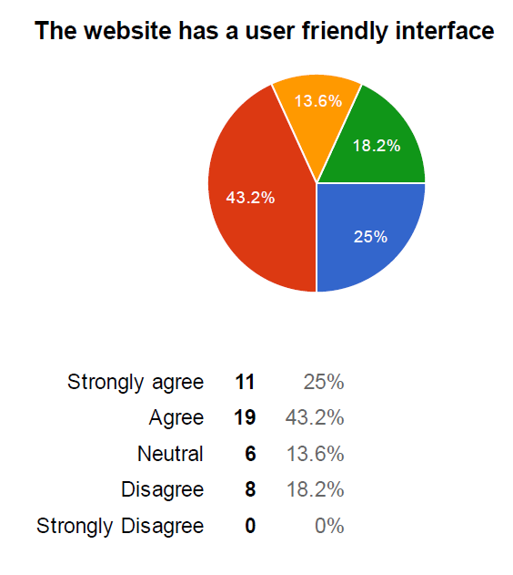 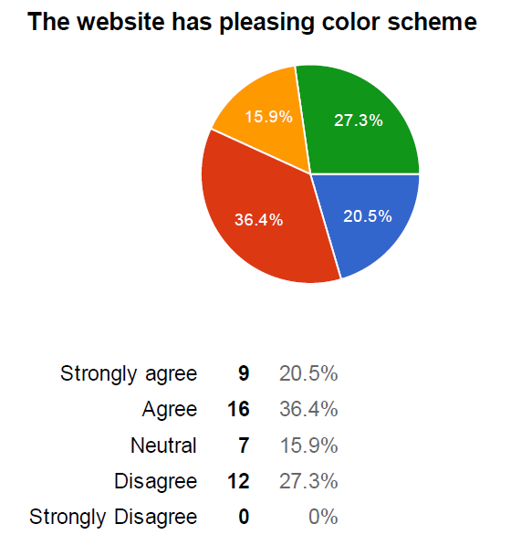

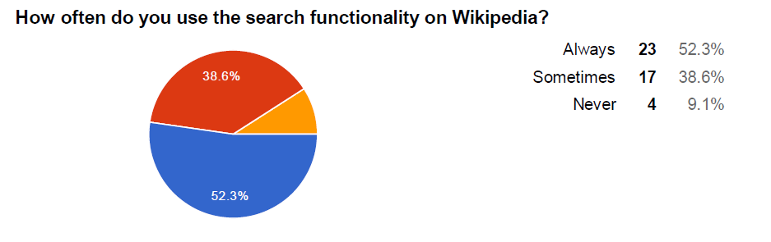

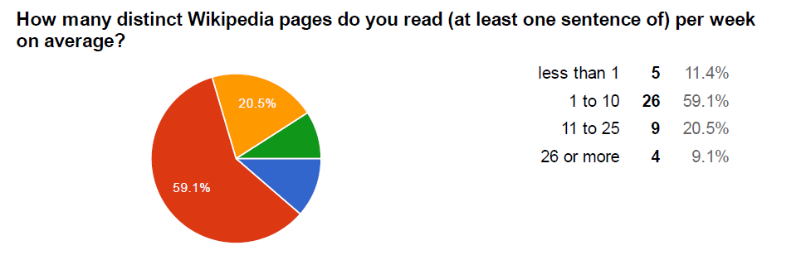

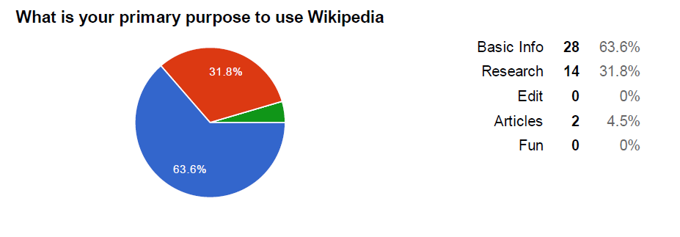

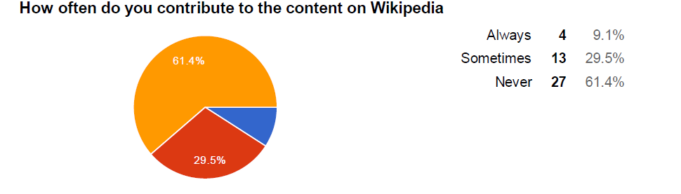

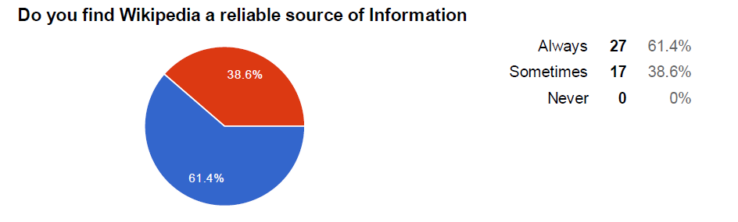

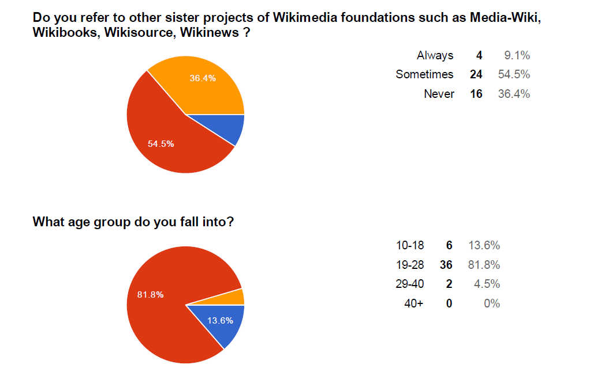



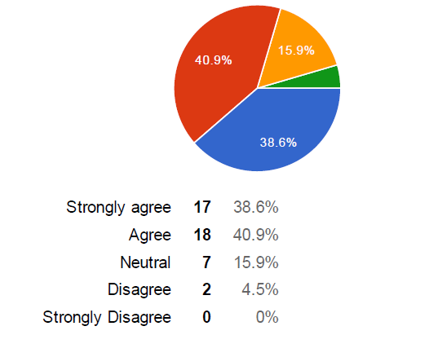

1. **Card Sorting –**

Card Sorting is a method used to design or evaluate the Information Architecture of a website. It helps us understand user’s expectations and understanding. In the card sorting session, participants organize topics into topics which makes sense to the user. There are two types of card sorting –

1. Open Card sort – Participants can create their own cards and categories.
2. Closed Card sort – Participants can sort the cards as per pre-defined categories.

In our project we used closed cart sorting.

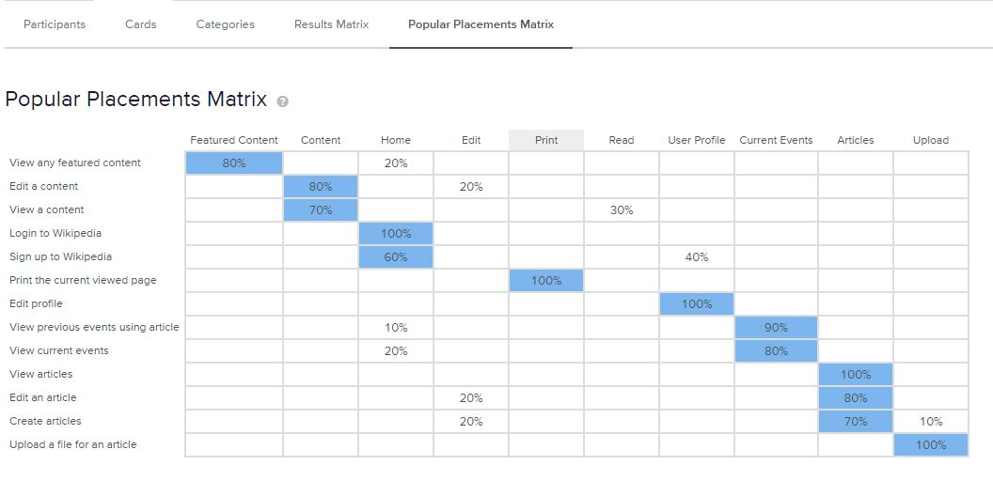

1. **A/B testing -** A/B testing is used for comparing two versions of the same application to determine the performance and usability of various elements and functions of the website. After finishing the wireframes, we had a conflicts about the design of the header, footer, brand logo and placing of few buttons and dropdowns. Due to this differences in opinion we decided to perform A/B testing to find which one will look more appealing to the users and find easy to use.

We created two versions of the master page which includes header, footer and main menu. Version 1 was created in wireframes using Moqups by Priyanka and version 2 was created in prototype using Axure RP 8.0 Version by Tejas. We showed both versions to different set of users. After analysing reviews from all the users we concluded that version 2 was much appealing to the user than version 1.

# Usability Testing

Usability testing helps us in determining if the website created was actually to the user and did it solve the purpose of creating a good user experience. This may include navigating through the website and performing other functions without any professional help or training.

For this testing we created 4 tasks and asked users to perform those tasks on the prototype created. We tracked and analysed the results for the tasks and they are stated below –

1. Whether the user has successfully completed the task
2. How much time did the user take to complete the task

We created following set of tasks –

1. User navigates through the home page and searched for Information, Search result page is displayed.
2. User navigates through the main page section to click on current events, Current event page is opened and selects a date to view the events.
3. User navigates through the Interaction section to click on About Wikipedia to view information about Wikipedia.
4. User navigates through the Interaction section to click on Community Portal to view information about Project Seeking Help, Portals and Outlines.

Below is the result observed after Usability Testing –

|  |  |  |  |  |  |  |  |  |  |
| --- | --- | --- | --- | --- | --- | --- | --- | --- | --- |
|  | **Completion Status** | | | | | **Time Taken in min** | | | |
| **Tasks** | **1** | **2** | **3** | **4** | **1** | | **2** | **3** | **4** |
| User1 | Complete | Complete | Complete | Complete | 3 | | 2 | 4 | 3 |
| User2 | Complete | Complete | Complete | Complete | 2 | | 1 | 3 | 2 |
| User3 | Complete | Complete | Incomplete | Complete | 2 | | 1 | 5 | 2 |
| User4 | Complete | Complete | Complete | Complete | 3 | | 2 | 3 | 3 |
| User5 | Complete | Complete | Complete | Complete | 2 | | 3 | 4 | 2 |

# Functional Testing

We also performed functional testing using Selenium IDE. We created a test plan to test the prototypes created in Axure using automation tool Selenium. The Test Plan, Test Results, Test Suites and the Test Cases are included in the submission folder.

# Technologies Used

We have used a lot of technologies throughout this project for various tasks which are listed below:-

1. Draw.io – Information Architecture
2. Moqups – Wireframes
3. Axure - Prototypes
4. StoryboardThat.com – Storyboards
5. Google Forms – Conducting Surveys
6. Selenium IDE – Functional testing
7. OptimalWorkshop.com – Card Sorting